FOREIGN TRADE UNIVERSITY
VIETNAM-JAPAN SCHOOL OF BUSINESS AND INNOVATION

==***==



ADVANCED BUSINESS ANALYST FINAL REPORT
HOTEL BOOKING CANCELLATION

Class: DBZ405E(DB-HK1-2627)K62.1
Group: 2
Lecturer: GS. Hồ Tú Bảo, PGS.TS. Trần Thị Oanh

Ha Noi, 2026
TABLE OF CONTENT
1. Strategic Problem Statement 4
1.1. Business Context 4
1.2. Business Pain Points 4
1.3. Stakeholders 5
1.4. Decisions to Improve 5
1.5. Strategic Objectives 6
1.6. SCQ Framework 6
2. PDMT Map 6
3. Detailed Expected Business Value 7
4. Data 9
4.1 Data sources and audit 9
4.2 Data architecture and schema 9
4.3 Data sources and features 10
4.4 Data preparation 11
4.5 Exploratory analysis and leakage checks 11
4.6 Example data extract 12
4.7 Integration challenges 12
4.8 Privacy and ethics 13
5. Method 13
5.1. Method 1: Cancellation Risk Prediction (ML) 13
5.1.1. Purpose and scope 13
5.1.2. Analytical design 13
5.1.3. Prototype analysis (mock results) 15
5.1.4. Evaluation plan: 15
5.2. Method 2: Risk-Based Decision Rules and Business Value 17
5.2.1. Purpose and scope 17
5.2.2. Analytical design 17
5.2.3. Prototype analysis (mock results) 20
5.2.4. Evaluation plan 22
REFERENCES 23

Strategic Problem Statement

Business Context
Scenario: City Hotel Lisbon sells perishable room inventory ahead of arrival, largely through travel agents and operators. Until the guest arrives, revenue is only expected, not secured.
Strategic issue: Revenue-management research identifies booking cancellations as a core source of demand uncertainty: they limit the accuracy of forecasts, and the usual responses, rigid cancellation policies and overbooking, can themselves damage revenue and reputation (Antonio et al., 2017). For City Hotel Lisbon, this means expected revenue and room plans cannot be fully relied on, and blanket policies are an imperfect fix. Cancellation is therefore a strategic revenue-risk problem, not just an operational event. Its scale is quantified in Section 1.2.
Cross-domain impact: One cancellation touches several domains at once, yet each is managed separately today, so no single view supports a joint decision.
Domain | Current state | Gap the project addresses
Distribution / Marketing | Cancellation risk differs sharply by channel and segment, but is not used in booking management. | Channel and segment risk guides booking management.
Customer Experience | At-risk guests are not systematically contacted. | Proactive, targeted contact for high-risk bookings only.
Finance | Commission, handling cost and revenue at risk are not linked. | Net value of actions accounts for cost.
Operations | Freed rooms are not systematically resold. | Resale and capacity decisions are guided by cancellation risk.
Transformation opportunity. Integrating booking, customer, cost and inventory data into one decision-support system can shift the hotel from reactive handling to risk-based, proactive booking management, optimizing revenue and room capacity.

Business Pain Points
Baseline: City Hotel Lisbon, 79,330 bookings, July 2015 – August 2017 (Antonio, Almeida & Nunes, 2019).
Pain point | Supporting data | Why it matters
Limited visibility into cancellation risk | 41.7% of bookings (about 33,000) were cancelled or no-show. 12% of cancellations occur within 7 days of arrival. | Late cancellations leave the least time to resell the room. Early warning is the only way to act before that window closes.
Inefficient allocation of follow-up resources | Travel agents and operators handle 87% of bookings. Cancellation rate ranges from 17.3% (Direct) to 68.9% (Groups). There is no systematic contact with at-risk guests. | Risk varies widely across segments, so uniform follow-up wastes effort on safe bookings and misses risky ones. Hospitality churn research supports targeting only high-risk guests rather than contacting everyone (van Leeuwen et al., 2025).
Limited ability to optimize revenue and room capacity | €10.9M of €25.3M gross booked room revenue (about 43%) is tied to cancelled bookings. Freed rooms are not systematically resold. Commission and handling cost are not linked to risk. | The hotel cannot tell which bookings to act on, or how to adjust follow-up, pricing, capacity allocation and resale so that revenue and occupancy are optimized net of intervention cost. Revenue-management studies show that cancellation-aware pricing, allocation and overbooking decisions can raise profit in simulation (Dong & Ling, 2015; Pimentel et al., 2019).
Note: €10.9M is gross booking value exposed to cancellation, not realized loss. Some of it is resold or recovered through deposits.

Stakeholders
Group | Role | Interest
General Manager, Revenue Manager | Decision-makers | Set priorities, resources and booking-management strategy; optimize revenue and capacity
Reservation Team | Operational users | Use risk information to follow up with guests and update room availability
Customer Service / CX | Operational users | Design and send guest messages; own opt-outs and CX KPIs
Finance | Decision support | Own cost and contribution assumptions; judge net value and ROI of interventions
Distribution / Sales | Operational users | Manage agents, tour operators and group-block contracts (release dates, deposits)
Data / Analytics Team | System owners | Build, calibrate and monitor the model; maintain the data pipeline and KPI reporting
Guests | Affected party | Experience the interventions; not direct system users

Decisions to Improve
Decision | Business question | Supported by
Risk identification | Which bookings are more likely to be cancelled? | Machine Learning
Resource prioritization | Which bookings should staff handle first when resources are limited? | Risk score + value proxy
Intervention selection | Should the hotel confirm, send a reminder or contact the guest directly? | Business rules
Revenue and capacity optimization | Which follow-up, pricing, allocation and resale actions improve revenue and occupancy at a justified cost? | Rule-based analysis + ROI analysis
Only the first decision is addressed directly by ML. The others need business rules, operational data and impact evaluation.

Strategic Objectives
Each objective follows from a pain point and a decision, and is backed by evidence.
 | Objective | Addresses pain | Improves decision | Evidence basis
1 | Identify cancellation risk early, before the final 7-day window | Limited visibility | Risk identification | 41.7% cancellation rate; 12% of cancellations within 7 days
2 | Allocate follow-up effort to the highest-risk, highest-value bookings | Inefficient allocation | Resource prioritization; intervention selection | 17.3%–68.9% segment gap; threshold-based targeting (van Leeuwen et al., 2025)
3 | Optimize revenue and room capacity by supporting follow-up, pricing, allocation and resale decisions, net of intervention cost | Limited ability to optimize revenue and capacity | Revenue and capacity optimization | €10.9M exposure; profit gains in simulated revenue-management studies (Dong & Ling, 2015; Cha, 2026)
The project does not aim to eliminate cancellations or guarantee revenue gains. Targets are reference pilot goals, to be confirmed through model evaluation (see Part 3).

SCQ Framework
Situation | City Hotel Lisbon sells rooms in advance. Over July 2015 – August 2017, 41.7% of 79,330 bookings were cancelled or no-show, tying up €10.9M of €25.3M gross booked room revenue.
Complication | 12% of cancellations occur within 7 days of arrival, when resale is hardest. Risk differs sharply by segment (Groups 68.9% vs. Direct 17.3%), yet at-risk guests are not systematically contacted, and commission and handling cost are not linked to risk. Manual review of every booking is not scalable.
Question | How might City Hotel Lisbon predict booking cancellation risk early, prioritize high-risk bookings, and recommend proportionate interventions to optimize revenue and room capacity?

Problem statement: How might City Hotel Lisbon predict booking cancellation risk early, prioritize high-risk bookings, and recommend proportionate interventions to optimize revenue and room capacity?

PDMT Map
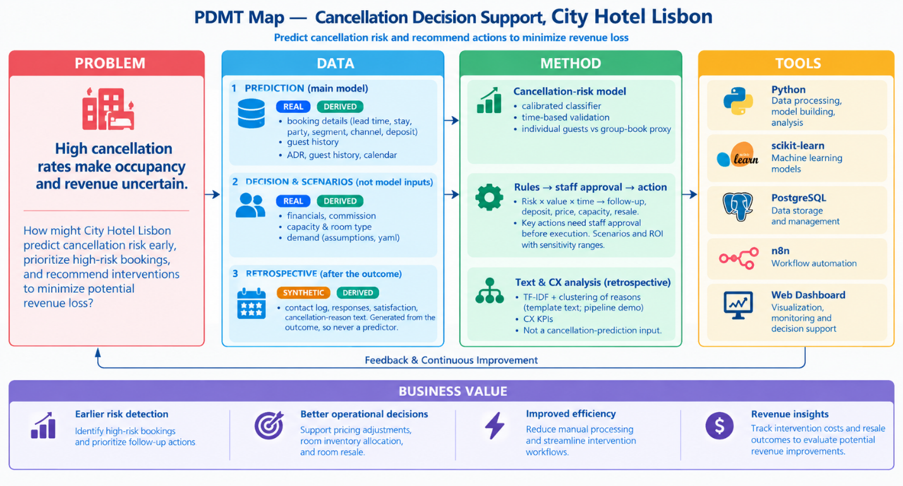

Detailed Expected Business Value
Baseline: City Hotel Lisbon, Jul 2015–Aug 2017 (41.7% cancellation rate). Targets without a sound benchmark will be set from model evaluation and baseline analysis. External benchmarks are pilot references from other settings.
Business function | Expected value and target | Evaluation and data
1. Cancellation risk prediction | Recall ≥ 70% on the test set: detect at least 70% of cancelled or no-show bookings, while limiting false alerts. | Recall, Precision, PR-AUC vs. a baseline model on an independent test set. Data: is_canceled, lead_time, deposit_type, previous_cancellations, booking_changes, market_segment, distribution_channel.
2. Risk-based prioritisation | Focus staff on the bookings with the most value at risk: each week, call the top 15% by risk × booking value and send reminders to the next 45%, within 20 call tasks a day. | Cancellation rate and share of cancelled value in the call and contact tiers, against the cancellation rate of the same weekly queue (2017: call tier 38.3% vs. 24.0%). Data: model risk score, booking value, is_canceled.
3. Customer experience and retention | Pilot target: a lower cancellation rate in the contacted tiers than in a randomised holdout, with no rise in opt-outs or complaints. Break-even is low: a call pays for itself if it prevents 1.1% of the cancellations it reaches, a reminder 2.0%. | Retention uplift (pp) = Retention(contact) − Retention(control); also response and cancellation rates. A control group is required for a causal claim. Data: contact_attempted, contact_channel, customer_response, is_canceled.
4. Finance and revenue recovery | Simulated net benefit of EUR 30.4k a year after variable costs and backfire losses; 3-year programme ROI of 173% and payback of 6.9 months after a EUR 15.6k one-off cost and EUR 3.4k a year running cost (Section 5.2). Assumption-based until the pilot measures the effect.  Reference: about 4% hotel profit gain from revenue-management optimisation (4.20% in a simulated overbooking scenario; Dong & Ling, 2015; see also Pimentel et al., 2019). A model benchmark, not a guaranteed gain. | Net recovery = Rebooking revenue − Incremental costs (commission, handling, staff). The €10.9M gross figure is not net recovery. Staff-cost floor: Portugal minimum wage €505–557 per month, 2015–2017 (Hans-Böckler-Stiftung, n.d.).
5. Room inventory and operations | Reference: at least 2.3% higher contribution profit when decisions are updated over time rather than optimised once (2.27% weekly booking-limit update; Cha, 2026). A dynamic-optimisation benchmark, not a resale-rate benchmark. | Resale rate = Rooms resold after cancellation ÷ Cancelled rooms eligible for resale; also unsold room-nights by arrival date. Compare operations with and without cancellation prioritisation.

Data
The data combine one real PMS extract with simulated tables that fill its gaps. Every field is labelled REAL, DERIVED (computed from real data), SYNTHETIC (simulated from a documented assumptions register) or SYSTEM (written later by the model, rules and n8n), so simulated figures are never presented as facts.

4.1 Data sources and audit
- Source: City Hotel Lisbon bookings from a hotel PMS extract (Antonio et al., 2019b): 79,330 of the file's 119,390 rows, arrivals July 2015 – August 2017, values recorded the day before arrival. The target is_canceled covers cancellations (40.6%) and no-shows (1.2%). The data are anonymised and match the published description on every check.
- Audit:
Issue | Finding | Decision
Missing values | company 95.4% and agent 10.3% empty (= none); country 24 rows, children 4 rows | Flag or fill
Duplicates | 25,902 rows (32.7%), mostly Groups; cancel 66% vs 30% | Likely block bookings: flag, keep
Invalid values | One ADR of EUR 5,400; 700 paid bookings with ADR 0; 331 zero-night and 167 zero-guest rows | Flag; impossible rows excluded
Week number | Not ISO weeks (0% match in 2016) | Rebuilt from the arrival date
- Preliminary EDA: 41.7% of bookings do not arrive, tying up EUR 10.9M of EUR 25.3M gross booked value (43%). Cancellation rises from 12% at 0–7 days lead time to 71% beyond a year, and ranges from 17% (Direct) to 69% (Groups). Notice is usually long (median 58 days), so many rooms can be resold in principle.
- Data gaps: The data predict well but lack what revenue decisions need: 12 of 17 data needs are missing, mainly room cost, commission, inventory, resale and guest contact. These are filled with labelled synthetic tables (Section 4.3); intervention uplift can only come from a pilot.

4.2 Data architecture and schema
All tables share one key, booking_id: booking-level tables join 1:1, and room inventory joins through the nights each booking covers.
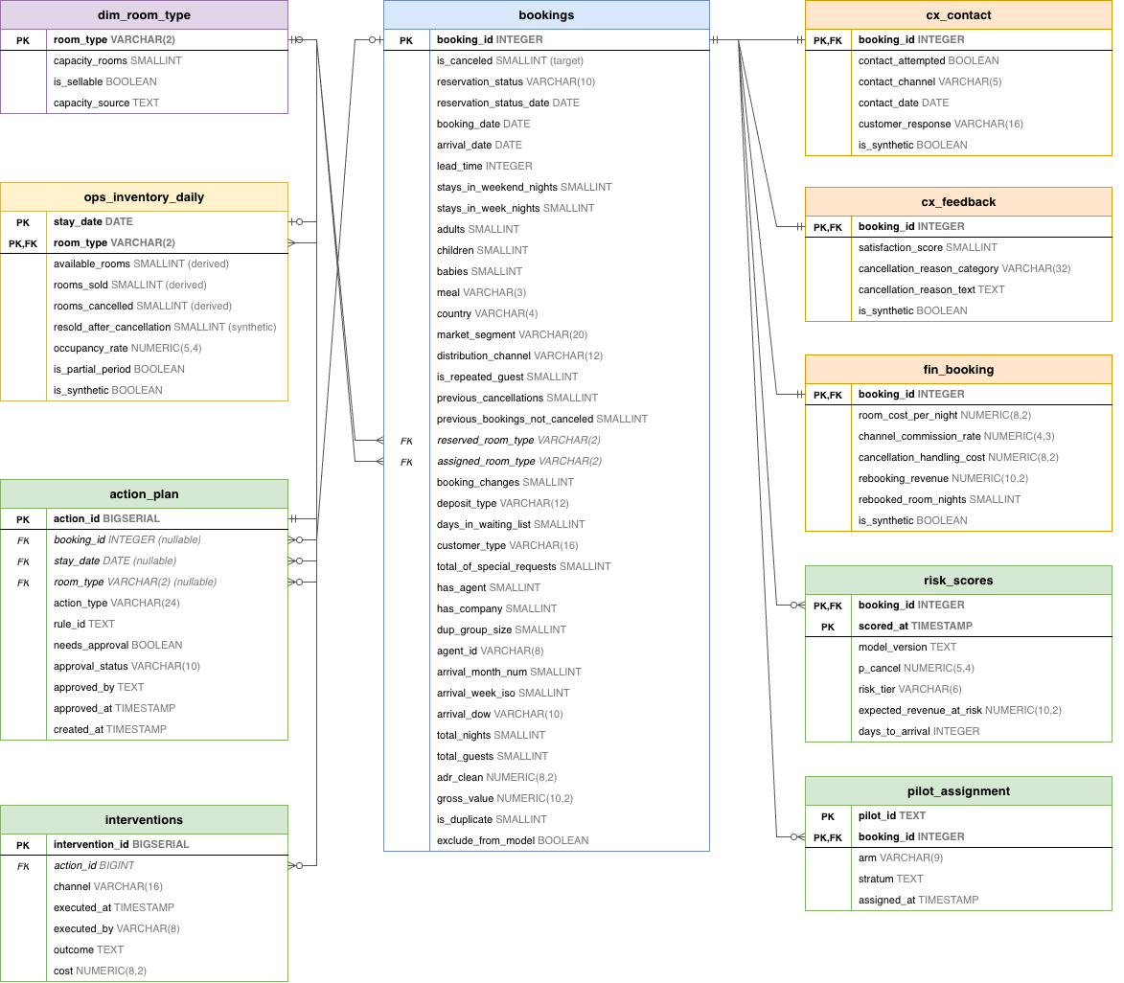
Simulated tables feed value-at-risk and scenarios, never the classifier. The schema runs in PostgreSQL with keys and CHECK constraints (for example, an action needing approval cannot run automatically) and passes 30 of 30 load checks; all 100 fields are documented in a data dictionary.

4.3 Data sources and features
- Real fields: Booking timing, stay and party, price (ADR), commercial attributes (segment, channel, deposit, customer type, agent) and guest history. Outcome fields, assigned room, country and booking_changes are never features (Section 4.5).
- Simulated data: All values come from one assumptions register, sourced for Lisbon or Portugal 2015–2017 where possible, each with a sensitivity range.
Field | Base value | Basis
Room cost per night | 27% of median ADR (room type × month) | Mandelbaum & McDade, 2017; Rushmore, 2011 (proxy); range 25–30%
Channel commission | Online TA 18%, Offline TA/TO 20%, Groups 10%, Direct 0% | (Toulon, 2014) weighted by OTA shares (Schegg, 2018)
Handling cost | 8–15 minutes × EUR 9.40 per hour | (“Salários médios sobem,” 2018)
Deposit retained | 0% (Non Refund tested up to 100%) | Team assumption: amount not recorded
Resale | 10–70% by notice × demand, at 90% of ADR | Team assumption; capped by rooms actually sold
Room capacity | 252 rooms (peak occupancy per type) | Derived; 71.3% occupancy in 2016 vs (“Hotelaria de Lisboa,” 2017)
Guest contact, response, satisfaction, reason | 30.1% contacted; response drawn from the outcome | Team assumption; workflow design only
On these assumptions, 50.7% of cancelled room-nights are resold, and cancelled bookings lose about EUR 3.8M in contribution net of resale. The loss falls to EUR 0.6M if Non Refund deposits are kept, so the deposit assumption matters most.
- Model features: The modelling set holds 78,892 bookings. The individual model uses 36 numeric and 7 categorical booking-time features (lead time, season, stay, price vs reference, history, top-15 agent, bookings on the books), plus 4 day-before-arrival fields in a secondary set. Feature statistics are fitted on training data only.

4.4 Data preparation
Cleaning keeps all 79,330 rows and flags problems instead of deleting them. Only 438 impossible rows (0.55%: zero guests or nights, the ADR error, undefined segment) are excluded, leaving 78,892 for modelling. Duplicates are kept and flagged, and results are reported with and without them. The simulated tables pass 39 validation checks and are joined 1:1 with the prefix syn_.
Bookings are split into two populations because they need different decisions:
Population | Rule | Bookings | Cancel rate: 2015–16 → 2017
Individual | All other bookings | 52,676 | 28.0% → 34.4%
Group / block | Groups segment, Non Refund deposit, or 5+ identical bookings | 26,216 | 64.2% → 66.7%
Data are split by arrival date: train up to December 2016, test January–August 2017, with October–December 2016 held out for validation.

4.5 Exploratory analysis and leakage checks
- Strongest signals: deposit type, agent, segment and lead time. Among individual guests the signal is weaker (special requests, last-minute booking, lead time).
- Group blocks cancel early (median 83 days before arrival) and in batches; individuals cancel later (36 days) and one by one.
- Season matters less than lead time × segment: monthly cancellation rates range only from 37% to 46%.
- Drift 2016 → 2017: new agents (PSI 1.09) and median ADR +16.5%, so agents are grouped as top 15 + other and ADR is measured against a reference.
- Leakage: Fields not known at scoring time are excluded: reservation status, booking_changes, assigned room type, parking requests, realised occupancy and all simulated fields. 'country' is excluded for fairness and because its booking-time value is unverified. EDA saw 2017 labels, so model choice and thresholds use the 2016 validation period.

4.6 Example data extract
A 30-booking stratified extract marks the origin of every column (real__, drv__, syn__). Three rows:
Case | Segment, deposit | Gross value (EUR) | Room cost per night (syn, EUR) | Commission (syn) | Resale revenue (syn, EUR)
Stayed, contacted by email | Online TA, No Deposit | 324.90 | 25.34 | 18% | –
Cancelled, resold | Online TA, No Deposit | 535.50 | 25.49 | 18% | 200.37
Cancelled, not resold | Groups, Non Refund | 192.00 | 24.70 | 10% | 0.00

4.7 Integration challenges
Challenge | Design response
Several systems (PMS, channel manager, email/SMS, accounting) with different IDs | One PostgreSQL schema keyed on booking_id, plus an ID mapping table
Booking-level vs night × room-type data | Separate tables joined through stay nights
Snapshot data vs live scoring | Time-stamped scores and actions; production keeps booking-change history
Real-time inventory | Refreshed by n8n from the PMS (batch in the prototype)
Real vs simulated figures | is_synthetic flag and syn_ prefix everywhere

4.8 Privacy and ethics
The public data are anonymised; a live system would fall under the GDPR, so the design adds four safeguards:
- Minimisation: the model uses no names or contacts; personal data stay in a separate, access-controlled table.
- Human review: deposit requests, hotel cancellations and relocations need staff approval (General Data Protection Regulation, 2016, Art. 22).
- Fairness: country is excluded from the model, and actions are monitored by segment and channel so no guest group is unfairly burdened.
- Transparency: guests are told that bookings are risk-scored, and reports label every simulated figure.

Method

5.1. Method 1: Cancellation Risk Prediction (ML)

5.1.1. Purpose and scope
Purpose: Score each individual booking by its cancellation risk at an early stage, so staff can prioritise a limited number of bookings for follow-up. The model ranks bookings. It does not make the final decision. The ranked list feeds Method 2 (rules → staff approval → action).
Scope:
- Individual bookings only. Group bookings (group_block) follow a separate operational rule.
- Target: is_canceled (cancelled or no-show).
- Data: real PMS extract, City Hotel Lisbon, Jul 2015 – Aug 2017.

5.1.2. Analytical design
Flowchart:
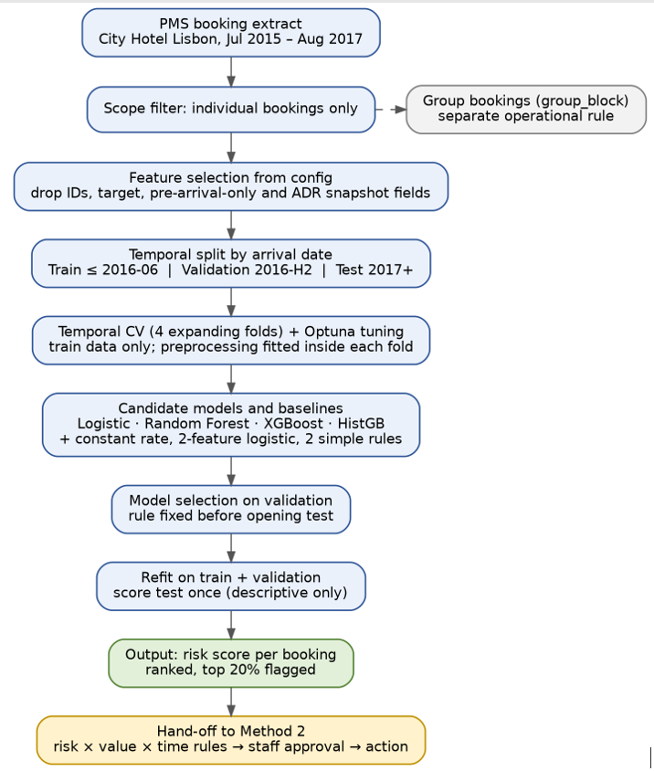
Figure 1. Method 1 analytical pipeline

Pseudo-pipeline:
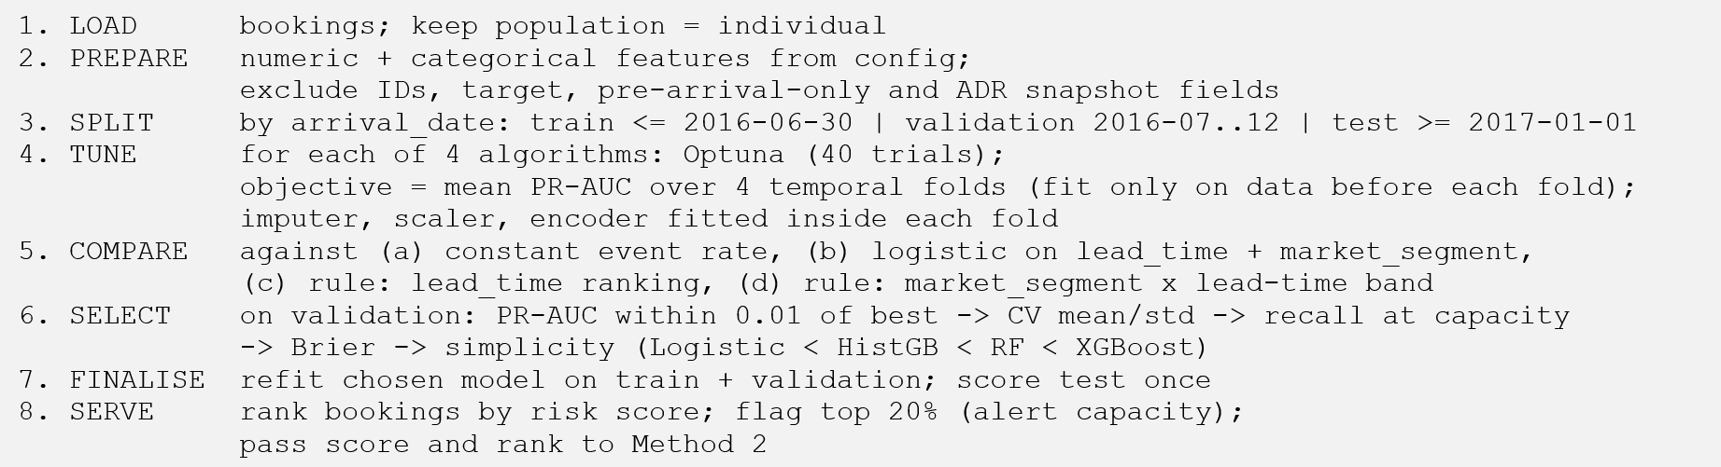

Model selection rationale:
We select models by how often their families appear in hotel-cancellation research and by what each does in a binary classification problem (Alkan, 2025; Chen et al., 2022; Devi & Rambabu, 2026; Hermawan et al., 2025; Luo, 2025; Phong et al., 2025; Yoo et al., 2024). XGBoost appears in 5 of 7 studies. Logistic regression appears in 4 of 7 and never ranks first. Falk & Vieru (2018) also use the same model family (probit) on 233,000 bookings for explanatory purposes.
What each model means for this classification problem:
- Logistic Regression (LR) models the log-odds of cancellation as a linear combination of features, passed through a sigmoid. It gives well-behaved probabilities and odds ratios (e.g., how much a non-refundable deposit changes the odds). Its limit is that non-linear effects and interactions must be specified by hand (Hosmer et al., 2013). It serves as the transparent benchmark for Finance and the Revenue Manager.
- XGBoost is regularised gradient boosting. Trees are built sequentially, each one correcting the errors of the previous ensemble by following the gradient of the loss (Friedman, 2001). XGBoost adds shrinkage, L1/L2 penalties on leaf weights, row and column subsampling and built-in handling of missing values (Chen & Guestrin, 2016). It reduces bias and is the most frequently used boosting implementation in the studies above (5 of 7). It is sensitive to hyperparameters, so it needs early stopping and a calibration check.
These two models represent the linear, bagging and two boosting approaches. They suit our data: 79,330 bookings, mixed numeric and categorical features, threshold effects (lead time) and interactions (deposit × segment). All two output probabilities, which the ranking (top 20%) and the ≥ 75% intervention rule require. The dataset is small enough for every model to receive the same tuning budget, so the comparison is fair.

5.1.3. Prototype analysis (mock results)
- Ranking, not classification. Operation is a top-k% queue sized to staff capacity, not a 0.5 cut-off.
- No leakage. Time-based split, preprocessing fitted inside each fold, test excluded from tuning and selection. Earlier scores above 0.80 were discarded because they came from leakage (group bookings mixed in, snapshot features, random split).
- Simplest adequate model. Logistic regression was selected. Tree models won temporal CV but lost on validation 2016-H2, so stability was preferred over complexity.
- Two checks that changed nothing. Re-tuning without the outlier first fold gave no validation gain (best-by-CV model 0.424 vs 0.457). Probability calibration (Platt, isotonic) worsened Brier, so raw probabilities are used.
Model | PR-AUC | Precision at Recall = 70% | Lift@20%
Logistic Regression
Random Forest
XGBoost
HistGradientBoosting

5.1.4. Evaluation plan:
Level | Measure | How | Success criteria | Result
Ranking quality | PR-AUC vs event rate, ROC-AUC | Block-bootstrap 95% CI (weekly blocks, 500 resamples) | PR-AUC clearly above event rate | 0.457 [0.438, 0.482] vs event rate 0.315
Operational value | Lift, precision, recall at top 5 / 10 / 20% | Same set; 20% = alert capacity | Lift@20% > 1 with CI lower bound > 1 | 1.48x [1.39, 1.56]; precision 0.464; recall 0.295
Added value over simple rules | Paired difference vs the 2 rules | Paired block-bootstrap | CI of the difference excludes 0 | Lift@20%: +0.23 vs lead-time rule and +0.23 vs segment×band rule (both CIs exclude 0)
Probability quality | Brier score, reliability curve | Validation set | Brier below constant-rate baseline | 0.201 vs 0.220; Platt (0.220) and isotonic (0.229) not applied
Temporal stability | CV fold scores; validation vs test | Fold-by-fold report | No unexplained collapse | Fold 1 is an outlier (~0.8 for all models, baseline 0.36); test lift@20% 1.59x, consistent with validation
Business value | Break-even: cancel rate in flagged group × save rate × booking value > intervention cost | Scenario table with sensitivity ranges (Method 2) | Positive net value under stated assumptions | See Section 5.2: break-even call uplift 1.1%, reminder 2.0%; S4 net benefit EUR 30.4k a year under base assumptions.
Causal effect | Cancellation rate and revenue retained, treated vs control | Pilot with control group (future step) | Significantly lower cancellation in treated group | Not yet available

Limitations:
- Validation and test labels were viewed during EDA, so results are a retrospective prototype. Test (2017) is descriptive and consistent with validation, not independent proof.
- lead_time and derived fields come from a near-arrival snapshot. As-of availability must be verified before deployment.
- The model screens rather than catches: recall at top 20% is about 30%, so about 70% of cancellations remain unflagged.
- The advantage over the baseline logistic (lead_time + segment) is small (+0.03 PR-AUC). The main value comes from using risk ranking to drive decisions.
- Drift risk: event rate differs by period (0.315 validation, 0.344 test), and agent_top and booking_month may be unstable over time (ablation not yet run).
- Cost, save rate and break-even rest on synthetic assumptions until a controlled pilot exists.
Monitoring after deployment:
- Alert share and queue size per week.
- Event-rate drift and PR-AUC / lift@20% on newly matured bookings.
- Stability of the agent_top and booking-month effects.
- Scheduled retraining on a rolling window.
Output to Method 2: Per booking: booking_id, risk score, risk rank (percentile), top-20% flag. Method 2 combines this with booking value and time to arrival to propose actions for staff approval.

5.2. Method 2: Risk-Based Decision Rules and Business Value

5.2.1. Purpose and scope
Purpose: Turn the Method 1 risk score into actions that staff can run every week, and test whether those actions pay for themselves. Method 2 answers three questions: which bookings to act on, what to do with each, and what the hotel gains net of all costs. Scope:
- Individual bookings, scored by the final Method 1 model (XGBoost). Group blocks follow separate rules (G1–G3), all approved by the Revenue Manager.
- Decision time: the end of each booking week. The queue holds bookings created that week that are still active and not yet arrived.
- Evaluation: the 2017 operational queue, 12,102 individual bookings in 35 weekly batches (cancellation rate 24.0%). The policy itself was chosen on 2016 data and frozen before 2017 was read.
- Money is measured on a contribution basis (room revenue net of commission, minus room cost). Uplift, cost and resale inputs are assumptions or simulated data (Section 4), not observed effects.

5.2.2. Analytical design
Step 1: Rank and tier each weekly batch.
- Call tier: the top 15% of the batch, ranked by p_cancel × booking value, so staff call the bookings where most money is at stake.
- Reminder tier: the next bookings by p_cancel, until 60% of the batch is covered.
- Low tier: the remaining 40%.
The shares (15% / 60%) and the ranking key were chosen on 2016 weekly batches with models fitted only on data available before each decision, from a grid of 42 candidate policies. Using shares of each batch, rather than a fixed probability cut-off, keeps the workload stable when the score level drifts.
Step 2: Route each booking to an action (Figure 5.2):
Rule | Condition | Action | Owner | Approval
I1 | Low tier, or reminder tier with 7 days or fewer to arrival | Standard confirmation + reminder 7 days before arrival (current practice) | n8n, monitored by Reservations | Automatic
I2 | Reminder tier, 8 days or more | Personalised e-mail/SMS at 30 and 14 days before arrival (max 2) | n8n, monitored by Reservations | Automatic
I3 | Call tier, 8 days or more | Phone call within 7 days of the decision and at least 8 days before arrival; max 20 call tasks per day; tasks without a free slot go to manual review | Reservations | Internal task
I4 | Guest asks to change during an I3 call | Offer a date or room change | Reservations | Revenue Manager if price changes (always, in the prototype)
I5 | Call tier, 7 days or fewer | No contact; count in the date × room-type cancellation buffer | Revenue Manager | –
I6 | Call tier, no deposit, high value | Request a deposit. Off by default | Reservations | Revenue Manager (GDPR Art. 22)
G1 | Group block, group-rule risk ≥ 0.5, > 30 days ahead | Ask the agent to confirm or release the block 30 days before arrival | Distribution / Sales | Revenue Manager
G2 | Released or forecast-cancelled rooms | Reallocate capacity and put rooms back on sale | Revenue Manager | Required
G3 | High forecast cancellations on a high-demand date | Controlled overbooking. Disabled: exploratory analysis only | Revenue Manager | GM sets limits
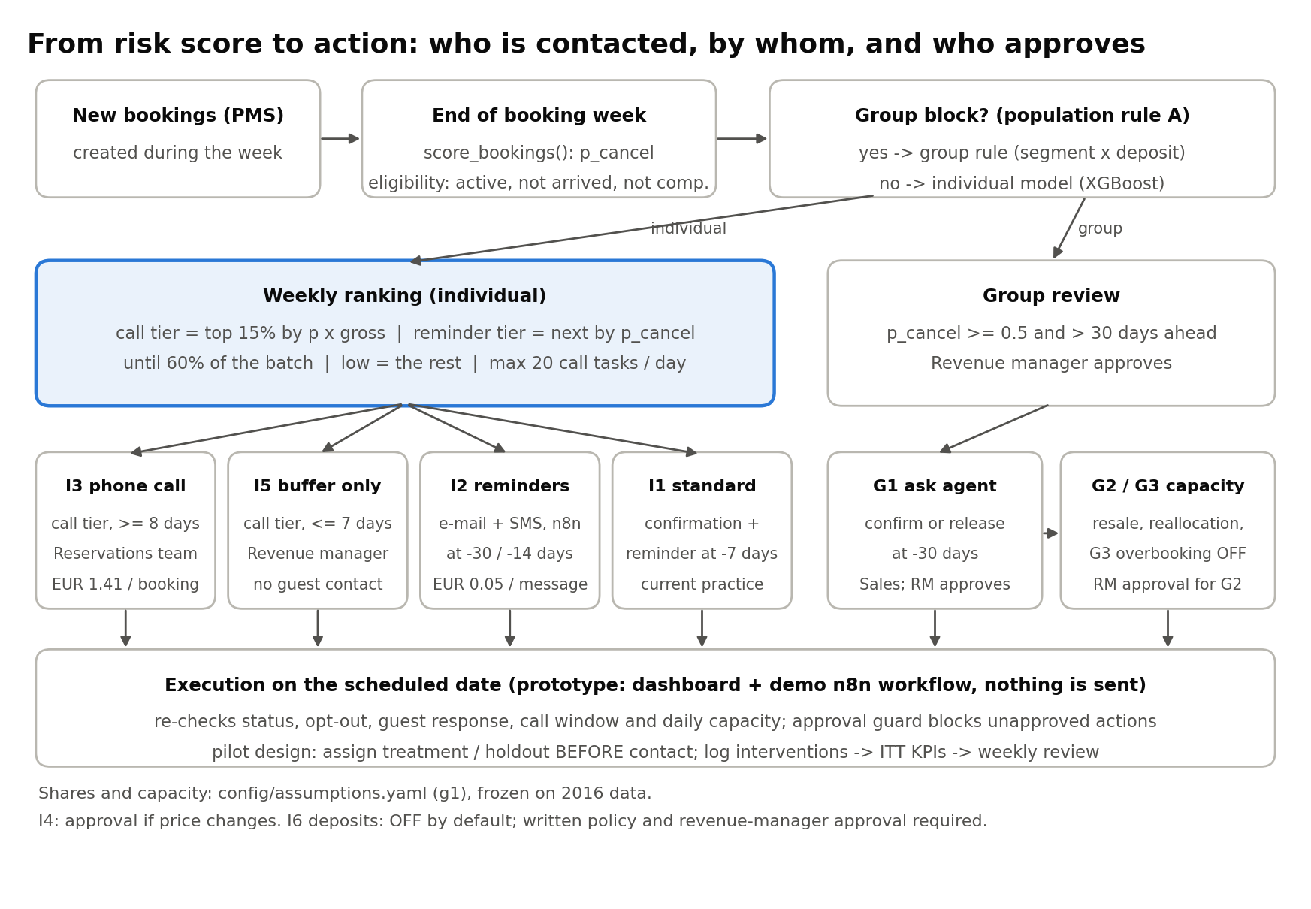
Figure 5.2. Decision workflow: from risk score to action
In production, n8n would run the automatic actions on their scheduled date after re-checking booking status, opt-out and guest response. In the prototype (Part 4) these checks, plus the call window and the daily call limit, run in the dashboard and again in a demo n8n workflow that sends nothing. Actions that change price, capacity or the guest’s obligations cannot run without approval.
Step 3: Value each action.
- Benefit: for a booking that would have cancelled, a contact prevents a share of the cancellation (the uplift). One prevented cancellation is worth the booking’s contribution minus what the hotel would have recovered anyway (resale contribution, less handling cost, plus any deposit kept). Late cancellations are worth more to prevent, because the room is harder to resell.
- Backfire: a reminder can prompt a guest who would have stayed to cancel, since 99.96% of individual bookings are No Deposit and free to cancel. This loss is subtracted.
- Variable cost: EUR 1.41 per call task (6 minutes × 1.5 attempts at EUR 9.40/hour) and EUR 0.05 per SMS. No cost is counted for bookings that cancel before their scheduled contact.
- Programme cost: EUR 15,564 one-off (integration, n8n workflows, dashboard, training) and EUR 3,360 per year (hosting, monitoring).
- Base assumptions: uplift 10% for calls and 3% for reminders; backfire 0% for calls and 0.5% for reminders. The reminder uplift is benchmarked well below the effect of SMS reminders on healthcare no-shows (Gurol-Urganci et al., 2013), because hotel cancellations are mostly deliberate.

5.2.3. Prototype analysis (mock results)
Scenario comparison (2017 operational queue, simulated, annualised):
Scenario | Calls | Reminder bookings | Cancellations prevented | Net benefit per year*
S0 Status quo | 0 | 0 | 0 | 0
S1 Reminders for all | 0 | 10,703 | 39 | EUR 3.1k
S2 Rule-based tiers (5% / 20%) | 586 | 1,810 | 27 | EUR 4.4k
S3 Model tiers, Method 1 default (5% / 20%) | 574 | 1,803 | 35 | EUR 12.6k
S4 G1 policy (15% / 60%, proposed) | 1,744 | 5,186 | 86 | EUR 30.4k
S5 S4 + group track (G1 release asks) | 1,744 | 5,186 | 86 | EUR 31.5k
*After variable intervention costs and backfire losses; before programme costs. Prevented cancellations are expected values over the 35-week queue.
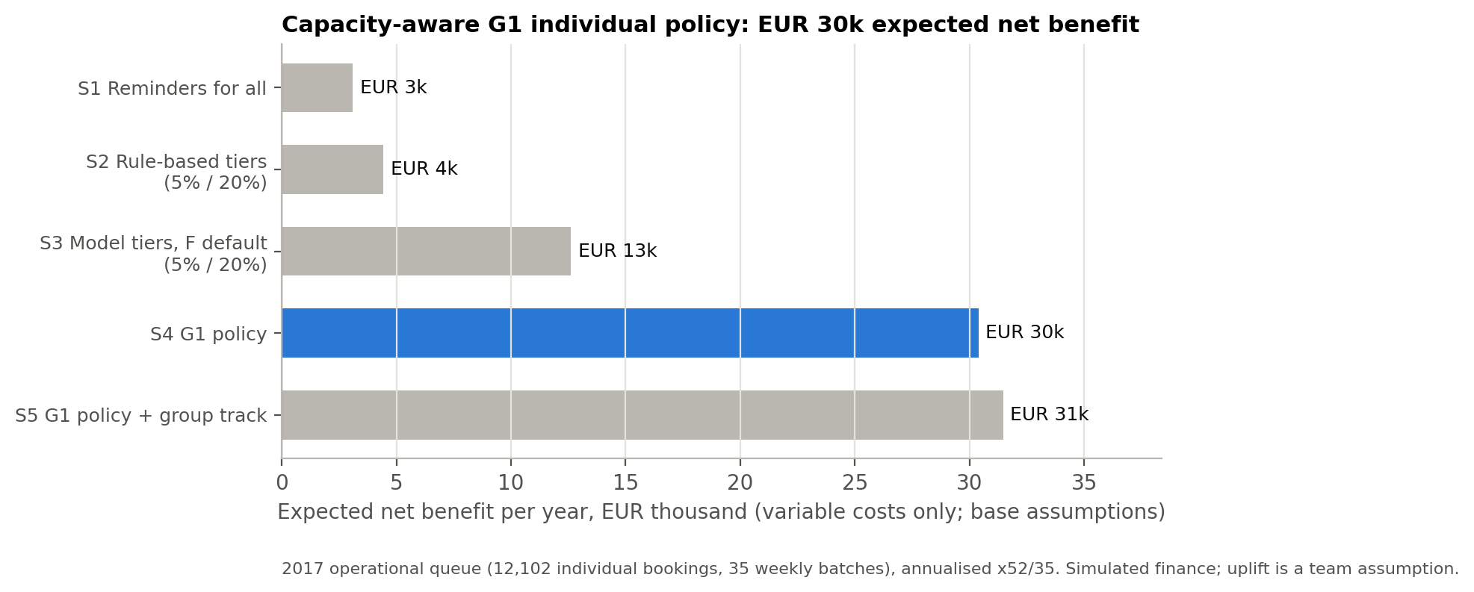
Figure 5.3. Net benefit per year by scenario (2017 queue, simulated)
Programme view (S4, 3 years, undiscounted): year-1 net EUR 11.5k after the one-off cost; 3-year net EUR 65.5k; ROI 173%; payback 6.9 months.
What the results show:
- Targeting by value matters more than contacting everyone. Reminders for all earn only EUR 3.1k, because backfire on low-risk guests almost cancels the benefit. Concentrating calls on the bookings with the most value at risk (S4) earns ten times more.
- The model adds value over a simple rule, but modestly. With the same 15% / 60% shares, ranking by the model earns EUR 30.4k a year against EUR 28.8k for a segment × lead-time rule.
- The case depends on the call uplift. A call pays for itself if it prevents 1.1% of the cancellations it reaches; a reminder needs 2.0%. If calls have no effect, S4 loses EUR 1.9k a year and programme ROI turns negative (–82%). If they prevent 25%, net rises to EUR 78.8k.
- Other assumptions move the result less. A reminder uplift of 0% or 8% gives EUR 25.5k / 38.5k; resale at half or one-and-a-half times the base gives EUR 40.3k / 20.5k; a reminder backfire of 2% gives EUR 22.4k and a call backfire of 1% EUR 26.5k; an implementation cost of EUR 30k instead of 15k lowers ROI to 95% (payback 13.6 months). Call time, attempts and SMS price each move the result by less than EUR 3.6k.
- Capacity holds. Calls average 16.5 per scheduled day and never exceed 20; 17 call tasks could not be scheduled in time and go to manual review.
- Overbooking (G3) stays off. The exploratory analysis loses EUR 0.7k a year after relocation costs, so it is not recommended without a new capacity design.
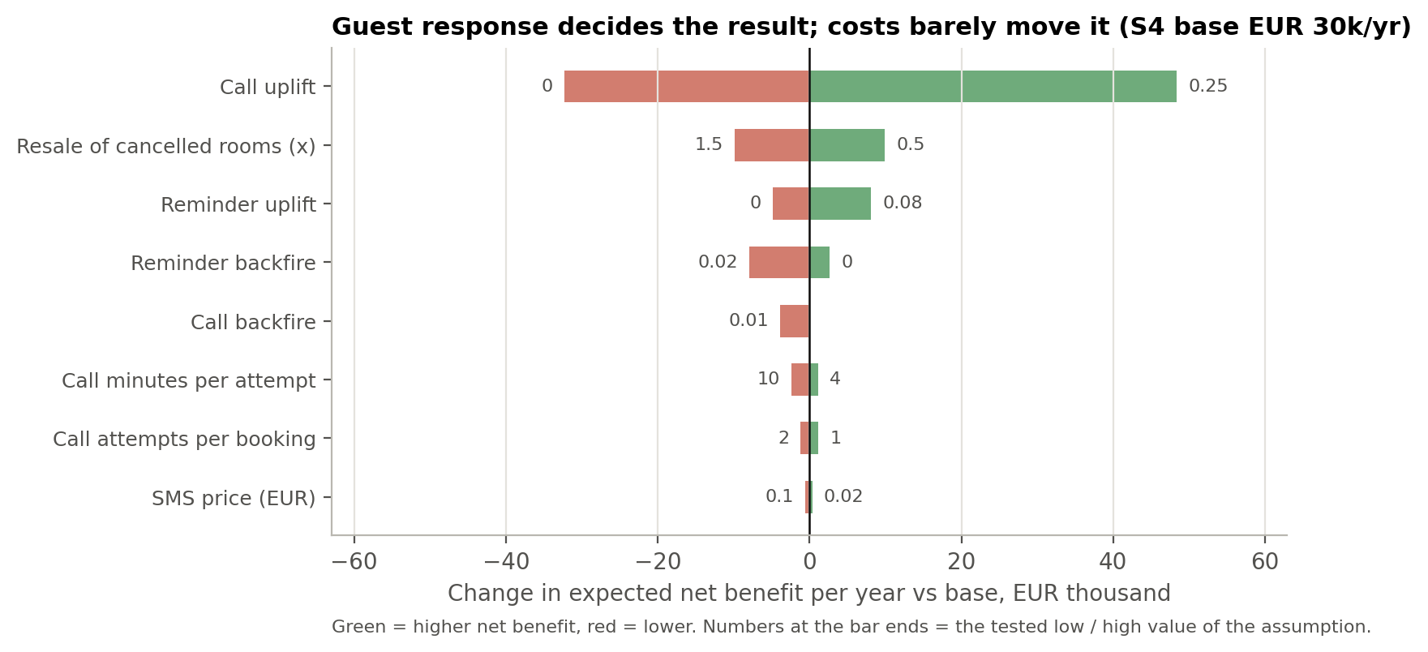
Figure 5.4. Sensitivity of S4 net benefit to each assumption
Occupancy, ADR and RevPAR (room-night ledger, stays 1 January – 31 August 2017, illustrative):
Scenario | Occupancy | ADR (EUR) | RevPAR (EUR) | Contribution net*
S0 Actual 2017 | 78.7% | 116.96 | 92.02 | –
S4 G1 policy | 79.0% | 117.22 | 92.59 | EUR +20.6k
S5 S4 + group early release | 79.0% | 117.20 | 92.63 | EUR +21.3k
S6 S5 + price ±5% (elasticity −0.8, assumed) | 76.8% | 121.37 | 93.16 | EUR +85.6k
*Over the period, after variable intervention costs, commission and room cost; before programme costs. Expected values from src/scenario_capacity.py, starting from the 48,182 of 61,236 room-nights actually sold. The S4 ledger result agrees with the queue simulation above (EUR 20.5k over 35 weeks). S6 raises rates by 5% on dates at 85% occupancy or more and cuts them below 60%; its price elasticity is a team assumption (the data has no price variation), and at −1.2 or −1.5 RevPAR falls instead, so S6 is a question for the pilot, not a recommendation. Overbooking (G3) is not simulated as an option.

5.2.4. Evaluation plan
Level | Measure | How | Success criteria | Current status
Queue control | Weekly queue size, call tasks per day, manual-review count | Action schedule and intervention log | Calls ≤ 20/day; manual review rare | Max 20/day; 17 tasks to review in 2017
Targeting quality | Cancellation rate and value share in contacted tiers | Same weekly queue as Method 1 | Lift > 1; model ≥ rule | Call tier: 38.3% cancelled vs. 24.0% in the queue (lift 1.60), 44.8% of cancelled value; call + reminder tiers: 87.4% of cancelled value. Model top 20%: precision 41.1% (rule 35.3%)
Business value | Net benefit, ROI, payback, break-even uplift | Scenario model with one-way sensitivity | Positive net under stated assumptions | S4 EUR 30.4k/year; ROI 173%; payback 6.9 months
Causal effect | Stay rate and contribution, treatment vs holdout | Randomised pilot: assign bookings to treatment or holdout before any contact, stratified by tier; analyse by assigned arm | Lower cancellation in treatment, with confidence interval | Not yet available
Guest experience | Opt-outs, complaints, cancellations right after a reminder (backfire) | CX monitoring by arm | No deterioration vs holdout | Not yet available
Pilot sizing: at one hotel, a one-year pilot can detect a reduction of about 5 percentage points in the call tier, while the assumed call effect is about 3.5 points. The pilot should therefore be read as a stop / redesign / scale decision with CX guard-rails, or pooled across more properties, rather than as proof of a precise effect.
Limitations:
- Uplift, backfire, cost and resale values are assumptions or simulated data. Results show the logic and its sensitivity, not a measured return.
- The policy was chosen with a historical model selected on 2015 data and refitted before each 2016 decision, then applied to the final Method 1 model; the pilot must confirm that it transfers.
- About 4,600 bookings in the 2016 selection queue had no final outcome at the freeze date, so very long-lead bookings are under-represented in the policy choice.
- Snapshot features and the group-block proxy are inherited from Method 1, so the 2017 results are a retrospective prototype.
Output to the system (Tools): a weekly action queue and a dated action schedule per booking (booking ID, risk score, tier, rule, action, planned date, approval need), with the 17 call tasks that found no slot flagged for manual review. In production n8n runs the automatic actions; in the prototype a demo n8n workflow checks and logs them without contacting anyone. Actions that need approval wait for the Revenue Manager.

REFERENCES

Antonio, N., de Almeida, A., & Nunes, L. (2017). Predicting hotel booking cancellations to decrease uncertainty and increase revenue. Tourism & Management Studies, 13(2), 25–39. https://doi.org/10.18089/tms.2017.13203

Antonio, N., de Almeida, A., & Nunes, L. (2019a). Big data in hotel revenue management: Exploring cancellation drivers to gain insights into booking cancellation behavior. Cornell Hospitality Quarterly, 60(4), 298–319. https://doi.org/10.1177/1938965519851466

Antonio, N., de Almeida, A., & Nunes, L. (2019b). Hotel booking demand datasets. Data in Brief, 22, 41–49. https://doi.org/10.1016/j.dib.2018.11.126
Ascarza, E. (2018). Retention futility: Targeting high-risk customers might be ineffective. Journal of Marketing Research, 55(1), 80–98. https://doi.org/10.1509/jmr.16.0163

Breiman, L. (2001). Random forests. Machine Learning, 45(1), 5–32. https://doi.org/10.1023/A:1010933404324

Cha, J. (2026). Machine learning-driven overbooking optimization under dynamic cancellation risk: Evidence from hotel revenue management. Computers & Industrial Engineering. Advance online publication. https://doi.org/10.1016/j.cie.2026.112341

Chen, T., & Guestrin, C. (2016). XGBoost: A scalable tree boosting system. Proceedings of the 22nd ACM SIGKDD International Conference on Knowledge Discovery and Data Mining, 785–794. https://doi.org/10.1145/2939672.2939785

Dong, Y., & Ling, L. (2015). Hotel overbooking and cooperation with third-party websites. Sustainability, 7(9), 11696–11712. https://doi.org/10.3390/su70911696

Falk, M., & Vieru, M. (2018). Modelling the cancellation behaviour of hotel guests. International Journal of Contemporary Hospitality Management, 30(10), 3100–3116. https://doi.org/10.1108/IJCHM-08-2017-0509

Friedman, J. H. (2001). Greedy function approximation: A gradient boosting machine. Annals of Statistics, 29(5), 1189–1232. https://doi.org/10.1214/aos/1013203451

Gurol-Urganci, I., de Jongh, T., Vodopivec-Jamsek, V., Atun, R., & Car, J. (2013). Mobile phone messaging reminders for attendance at healthcare appointments. Cochrane Database of Systematic Reviews, (12), CD007458. https://doi.org/10.1002/14651858.CD007458.pub3
Hans-Böckler-Stiftung. (n.d.). WSI minimum wage database: Portugal. https://www.boeckler.de/pdf/ta_portugal_mwdb.pdf

Hosmer, D. W., Lemeshow, S., & Sturdivant, R. X. (2013). Applied logistic regression (3rd ed.). Wiley.

Iberian Property. (n.d.). Lisbon, Porto and the Algarve attract more hotel investors [JLL data]. https://iberian.property/news/archive/lisbon-porto-and-the-algarve-attract-more-hotel-investors/

Ke, G., Meng, Q., Finley, T., Wang, T., Chen, W., Ma, W., Ye, Q., & Liu, T.-Y. (2017). LightGBM: A highly efficient gradient boosting decision tree. Advances in Neural Information Processing Systems, 30, 3146–3154.

Lusa. (2017, June 6). Em 2016, abriram em Portugal mais 81 empreendimentos turísticos [Deloitte Atlas da Hotelaria data]. ECO. https://eco.sapo.pt/2017/06/06/em-2016-abriram-em-portugal-mais-81-empreendimentos-turisticos/

Pedregosa, F., Varoquaux, G., Gramfort, A., Michel, V., Thirion, B., Grisel, O., Blondel, M., Prettenhofer, P., Weiss, R., Dubourg, V., Vanderplas, J., Passos, A., Cournapeau, D., Brucher, M., Perrot, M., & Duchesnay, É. (2011). Scikit-learn: Machine learning in Python. Journal of Machine Learning Research, 12, 2825–2830. https://jmlr.org/papers/v12/pedregosa11a.html

Pimentel, V., Aizezikali, A., & Baker, T. (2019). Hotel revenue management: Benefits of simultaneous overbooking and allocation problem formulation in price optimization. Computers & Industrial Engineering, 137, Article 106073. https://doi.org/10.1016/j.cie.2019.106073

Talluri, K. T., & van Ryzin, G. J. (2004). The theory and practice of revenue management. Springer.

van Leeuwen, R., Do, H. D., & Koole, G. (2025). Churn management in hospitality. Journal of Big Data, 12, Article 145. https://doi.org/10.1186/s40537-025-01204-8

Antonio, N., de Almeida, A., & Nunes, L. (2019b). Hotel booking demand datasets. Data in Brief, 22, 41–49. https://doi.org/10.1016/j.dib.2018.11.126

Hotelaria de Lisboa tem recorde de receita por quarto [Lisbon hotels post record revenue per room]. (2017, February 2). PANROTAS. https://www.panrotas.com.br/noticia-turismo/hotelaria/2017/02/hotelaria-de-lisboa-tem-recorde-de-receita-por-quarto_143945.html

Mandelbaum, R., & McDade, G. (2017, February 21). The rising cost of rooms. LODGING Magazine. https://lodgingmagazine.com/the-rising-cost-of-rooms/

Regulation (EU) 2016/679 of the European Parliament and of the Council of 27 April 2016 on the protection of natural persons with regard to the processing of personal data and on the free movement of such data (General Data Protection Regulation). (2016). Official Journal of the European Union, L 119, 1–88. https://eur-lex.europa.eu/eli/reg/2016/679/oj

Rushmore, S. (2011, November 7). Comparing same hotel across five regions. HVS. https://www.hvs.com/article/5529-comparing-same-hotel-across-five-regions

Salários médios sobem no turismo, mas ainda não vão além dos 632 euros [Average wages in tourism rise but still do not exceed 632 euros]. (2018, February 19). Diário de Notícias. https://www.dn.pt/dinheiro/interior/salarios-medios-sobem-no-turismo-mas-ainda-nao-vao-alem-dos-632-euros-9128393.html

Schegg, R. (2018). European hotel distribution study: Results for the reference year 2017. Institute of Tourism, HES-SO Valais; HOTREC. https://turob.com/assets/Haberler-Dosyalari-image/European-hotel-distribution-study-final-results.pdf

Toulon, A. (2014, May 28). Booking, Expedia… les hôteliers sont-ils vraiment perdants ? [Booking, Expedia… are hoteliers really the losers?]. Europe 1. https://www.europe1.fr/economie/Booking-Expedia-les-hoteliers-sont-ils-vraiment-perdants-660490

